Ryan Francis

**The American Home Equity Question, an Investment or a Source of Credit**

**Introduction**

In America there is a common perception that owning a home is a long-term investment that will aid a household’s ability to grow their wealth. The traditional idea of home ownership includes a family purchasing a house, typically with a mortgage, and slowly paying off that mortgage which builds up their home equity, thus increasing their net worth. This notion is only accurate if American’s themselves view housing as an investment, not a potential source of credit usable for consumption. Home equity, given its two plausible theoretical interpretations of use, needs a unit of pricing to measure so we can quantify how it is viewed among the American populace.

Before we dive into the analysis, I’ll define the terms and concepts that will be discussed. Home equity is the value of the ownership a homeowner as in their home. It is defined as Home Equity = Home Value – Debt against the home. As seen in the equation home equity can increase from either the value of the house going up or the debt against the home to go down. Typically, in America households take out a loan to buy their homes, the most common of which is a 30-year mortgage. Additionally, there is another type of home loan commonly used, the home equity line of credit. Often abbreviated as HELOC, this mortgage product acts as a revolving line of credit. Typically, banks will grant the consumer a line of credit up to the point where homeowners would have roughly 20-25 percent remaining equity in their homes. Given this fact, this product is only available to people who have built up equity past the 20-25 percent threshold.

This problem can be solved by looking the price of home equity, the interest rate of the loan against a home, and how home equity changes as the interest rate changes. In this paper we will take a look at the most common type of home loan, a 30-year mortgage, as well as revolving home debt such as a home equity lines of credit. It is appropriate to look at both of these home loans due to the 30-year being the most common type and HELOC’s being short term loans.

There have been many researchers that look at the household borrowing on real estate. Previous work has showed that credit for households has rapidly expanded housing prices has led to increased household leverage. Mian and Sufi (2011) demonstrate in their paper “House Prices, Home Equity Based Borrowing, and the US Household Leverage Crisis” that as housing prices rose, so did consumer’s ability to borrow from their increased equity. They cited the fact that approximately 65% of homeowners owned their homes before the acceleration in home prices, giving Americans the ability to increase their debt to income ratio much higher than they otherwise would have been able to. This closely relates to the type of analysis that this paper aims to do, I am aiming to determine if Americans view home equity as an easy form of colleterial to borrow against or as a form of saving. One way that my paper is different is they used anonymous data from individual homeowners while I used aggregated data. In my model I also differentiate short term equity borrowing with long term mortgages while they do not. This proves to be a critical distinction later in my analysis.

**Data**

All the data used in this project was retrieved from the Federal Reserve of Saint Louis. It is quarterly data from 1990 to 2018, the largest dataset available for all the relevant variables. That data includes the 30-year interest rates, the HELOC rates, the CPI for Housing, and Home Equity in units of billions. The picture below shows how interest rates have been trending in my dataset over time.

The next chart shows the changes in home equity over time.

This is the trend when both are charted together.

**Model’s and Methods**

The first model I’ll implement this project would be a time series linear regression over the aforementioned variables. We will then implement a lag in the independent variables to measure the effects a previous quarter change in interest rates will have in the quarter thereafter.

Interpretation of coefficients: A positive coefficient for both the 30 Year Mortgages and HELOCs would imply that as interest rates decrease so would home equity. This would suggest that home equity is viewed as a form of borrowing, that as the interest rate drops the relative price of borrowing drops, making tapping into home equity relatively cheaper. A negative coefficient would imply the opposite, that there is an inverse relationship between home equity and interest rates. This would that as interest rates go down, home equity would go up, implying that Americans view their homes as a form of saving, with their home loans becoming relatively cheaper to pay off.

**Results**

The two tables below show a simple regression without a lag with both the interest rates.

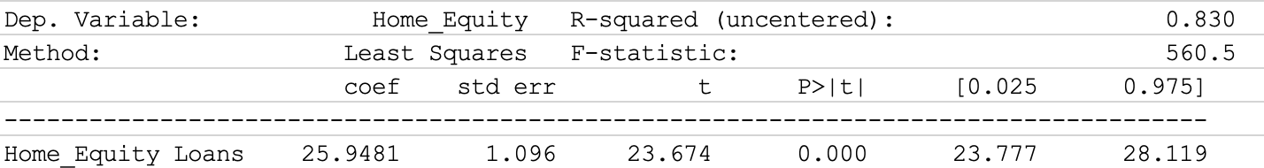

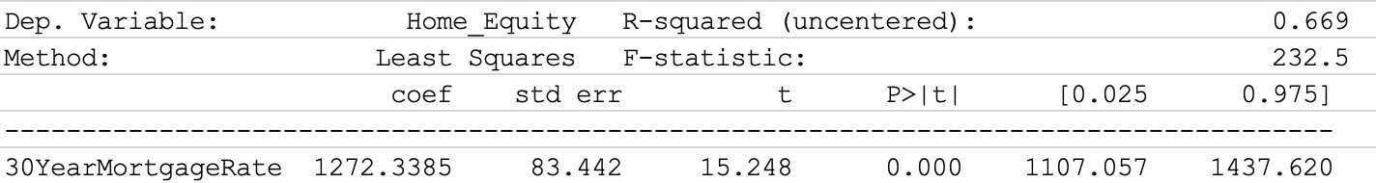

These two single variable regressions show that there is a statistically significant correlation. However, this model is not robust enough to show causation. The next model I ran takes into account the CPI for housing to make the model less biased and hopefully approach causality.

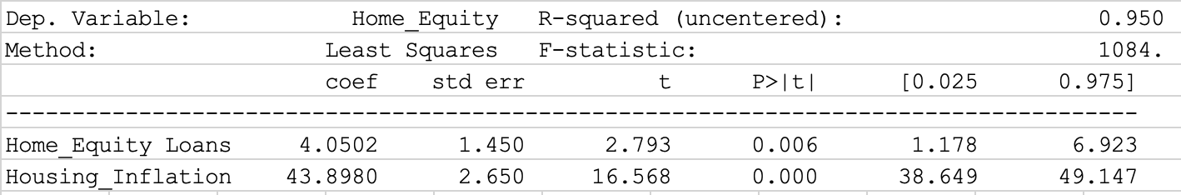

This model shows that when the CPI for housing is taken into account, the positive effect of the interest rates on HELOCs is significantly smaller.

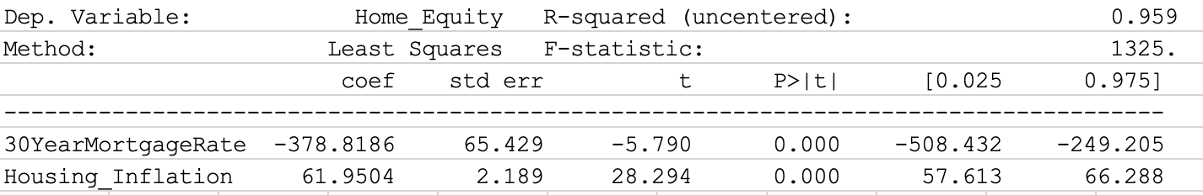

This model flips the 30-year interest rate from having a positive relationship to an inverse relationship.

**Lagged Models**

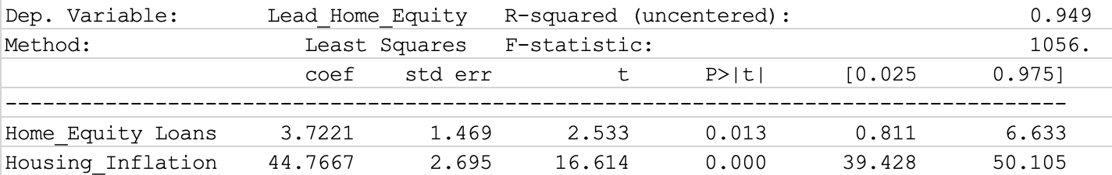

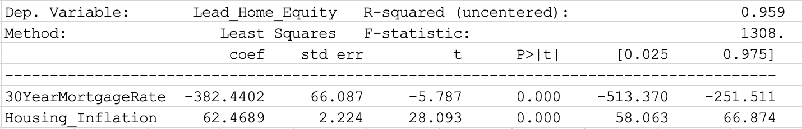

The above tables show the results when the dependent variable is moved up one quarter in time to give the independent variables a lagged effect. When the tables are compared to their unlagged counterparts, the difference in magnitude is minimal and does not change any of the underlying arguments that could be made from interpreting the tables. This is due to the fact that changes in interest rates are slow across periods and any change from one period wouldn’t be vastly different from the previous period.

It is worth noting that the different types of loans produce different effects on home equity. The positive relationship with home equity loans and home equity shows that interest rates and equity comove together. This means that the consumers that use HELOC’s view as their home equity as collateral for short term borrowing. When the 30 Year mortgage rate is regressed against home equity, we find that it has an inverse relationship. This means that as interest rates go down, home equity goes up. Given that this is the most common type of loan, this shows that broadly home equity is viewed as a form of saving.

**Auto Regressive Model**

As a last form of analysis, an autoregressive model was run. See the results below.

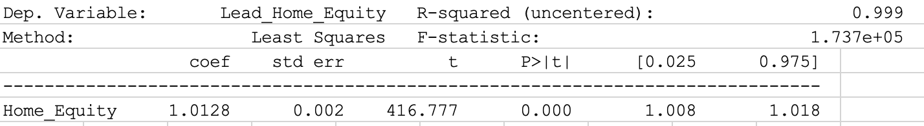

This shows a slight positive relationship between Home Equity at time t-1 and Home Equity. This means home equity can predict itself one period in the future with a high degree of certainty.

**Robustness Check**

This paper does not address several potential factors that could be relevant in this analysis. Lower interest rates cause consumers to be able to afford larger mortgages, causing prices to increase for the entire market. This favors households that have purchased their homes in higher interest rate environments, appreciating their homes at a rate higher than normal as interest rates drop. These households could further benefit from dropping rates by refinancing their homes at the lower rate, increasing the rate of increase of equity per payment by dropping the percentage of the payment going to interest. This double dipping effect would not be captured in my model and would require a much more robust and cleverer model than I am capable of producing to capture it.

Another factor that is not captured is the presence of real estate investors in the market. Real estate investors are not motivated by the same factors that regular homeowners are and would not respond to the same market forces in the same way. They look at housing as purely an investment tool and would be concerned with metrics such as cash flow and potential appreciation.

**Conclusion**

In conclusion, different loan products target different segments of the American population. When the natural increase in housing prices is taken into account, lower HELOC rates encourage more housing debt while lower 30-year mortgage rates encourage less housing debt. Given this knowledge, we can better anticipate how changes in monetary policy will affect consumer behaviors with regards to housing. This is helpful knowledge if we wish to avoid Americans from overleveraging on their homes and to promote housing stability.